**Credit Card System**



**Under the guidance of**

**Krishnaraj Damodarasamy**

**Mentor (Cognizant)**

**Submitted by**

**Team -1**

**Hello World**

**Ayush Jain**

**Avinash Kumar**

**Harsh Yadav**



**Contents**

1. **Introduction 3**

* 1. **About The document 3**
     1. Purpose & scope 3
     2. Intended Audience 3

* 1. **About Software System 3**
     1. Scope Of System 3
     2. Exclusions
     3. System Prospective 4
     4. Impact of System 4
     5. Assumptions 4
     6. Data flow Diagram 5

1. **System Requirements 6**

* 1. **Functional Requirements 6**

* + 1. Customer Details Module 6
    2. Bank Admin Module 6

**2.2 Technology Stack 6**

1. **Data analysis 6**

1. **Appendix 9**

1. **Introduction**
   1. **About this document**
      1. **Purpose and scope of the document**

The Purpose of the document is to mention the functional and non- functional requirements for the project credit card system and to mention all the necessary details related to the Project.

The scope of the document is to list all the requirements specification in the formal way.

* + 1. **Intended Audience**

Team members and Mentor.

* 1. **About Software System**

Credit Card System is a windows based application that deals with the approval of credit card. It is reasonable for administration of credit card. It includes the details of the user he can check whether he is applicable for applying the credit card, he can check the credit score and If he is applicable then he can apply for the credit card and can select which type of card he wants.

* + 1. **Scope of System**

The scope of the System is explained through its module:

1. Customer details – This module will be used by the existing customers of bank. They can see there bank account details by logging in and they will also be able to request for the credit card.
2. Bank Admin – This module will be used the bank admin. He will be able to see the pending request, approved request of the credit card. He will also see the customer details and some reports.
   * 1. **Exclusions**

This system includes all the functional requirements and modules which is mentioned in this document. It will not exclude anything.

* + 1. **System Prospective**

The credit card system is a windows based GUI application which is developed for the bank customers and admin so that customers can easily apply for credit card online without manually visiting the bank and bank admin can easily manage the data.

* + 1. **Impact of the System**

This project is developed for the existing customers for the bank so that they can easily check their eligibility and can apply for the credit card if they are eligible. As the process will be only so they do not need to manually visit the bank it will save a lot of time of customer and bank also.

* + 1. **Assumptions**

1. Customers must already have registered in the bank
2. Admin has the access of the information of customers which are applying for credit card

**1.2.6 Data flow Diagram**

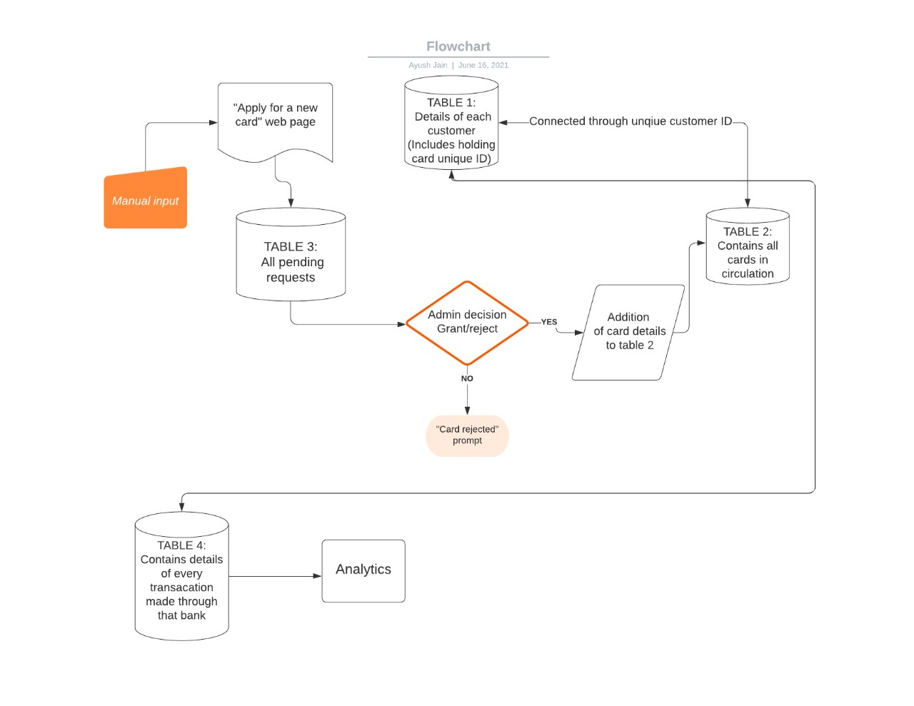

1. **System Requirements**
   1. **Functional Requirements**
      1. **Customer Details Module**
2. User can login through id and password.
3. User can see all the account details.
4. User can check whether he is applicable for applying credit card or not.
5. User can check his credit score.
6. User can apply for the card be selecting which type of card he wants and with what monthly limit.

* + 1. **Bank Admin Module**

1. Admin can see all the details of the customer**.**
2. Admin can see all the pending and approved request.
3. Admin can approve or decline request for the credit card by validating customer’s information.
4. Admin can see and analyse different reports
   1. **Technology stack**

Front end: Tkinter (Python)

Back end: MySQL, Python

Report tool: Pandas and matplotlib

1. **Data analysis**

Some Screenshots of the analysis of customer’s data are mentioned below.

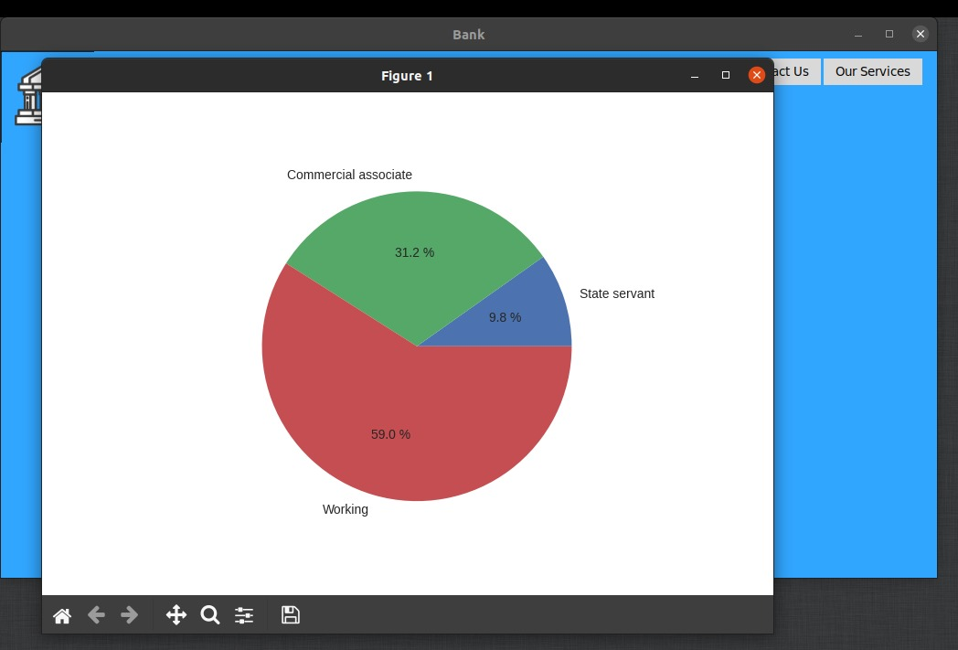 **Fig 1:** Profile of customer’s applying for the credit card

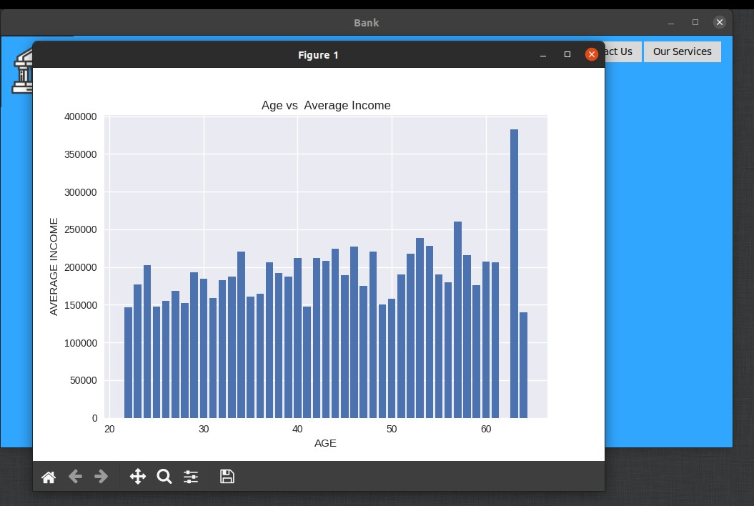

**Fig 2:** Age vs Average income of the customer’s

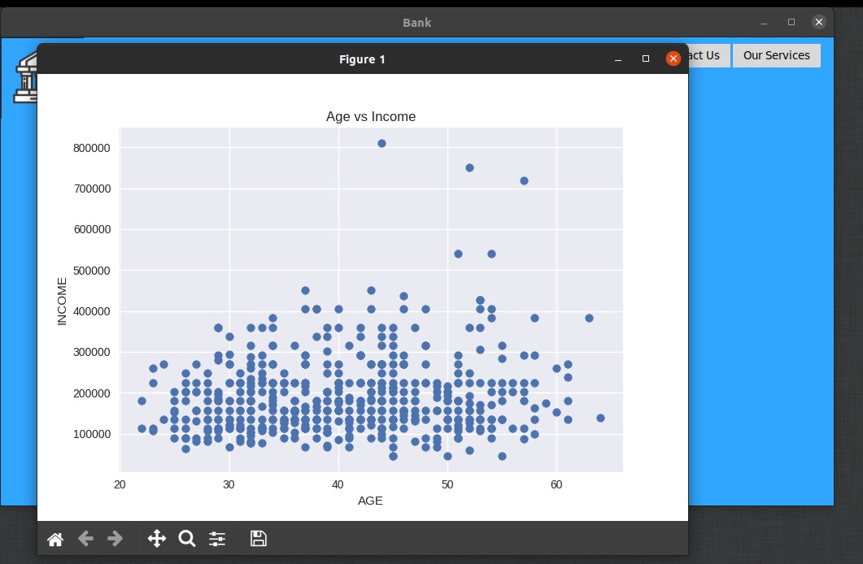**Fig 3:** customer’s Age vs their income

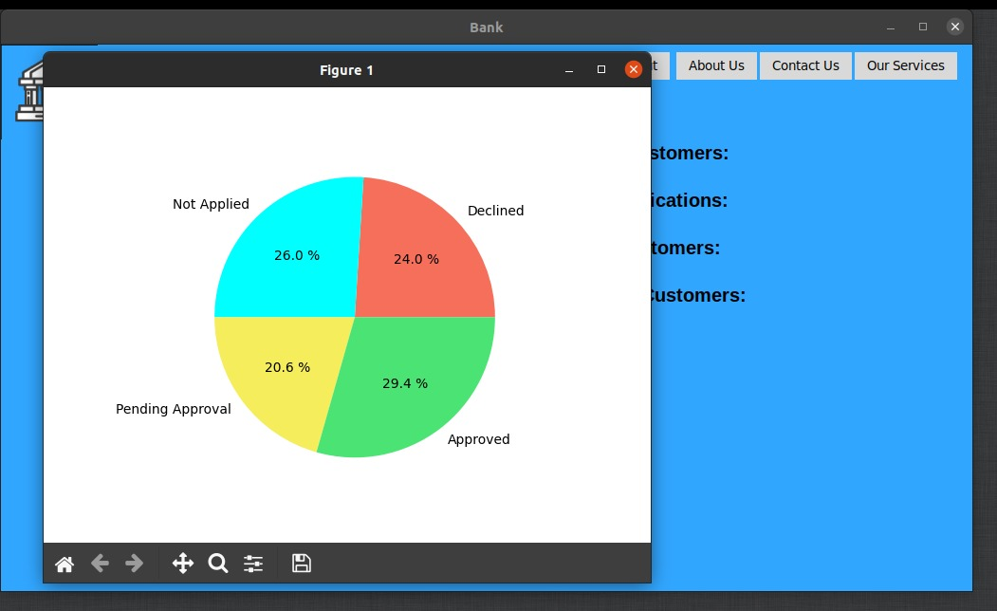

**Fig 4:** Graph of the request for approval of credit card

1. **Appendix**